Lab 1 site assessment journal. Brennan Giles

The significance of this site to me is that this is where my family lives and has lived while I’ve been away at college. Being able to drive home after a term at Corvallis to this place always fills me with joy.

What I remember about the soil is that it is very fertile with a lot of organic matter. This may not make sense but it is some of the “healthiest” soil I know of. It is dark brown and almost entirely soil with only a sparse amount of small rocks inside.

The dominant soil series is the “Quatama Series”.

The typical pedon structure is “Quatama loam, cultivated”. At the top it is loamy, brown, moist with moderate fine and very fine subangular blocky structure. It is moderately acid and tends to have fine roots embedded within it. I’ve never tasted the soil outside my house so I didn’t know it was acidic, but other than that I think I had it spot on from memory. For some context, this area was historically extremely fertile and used as a farming location in the past.

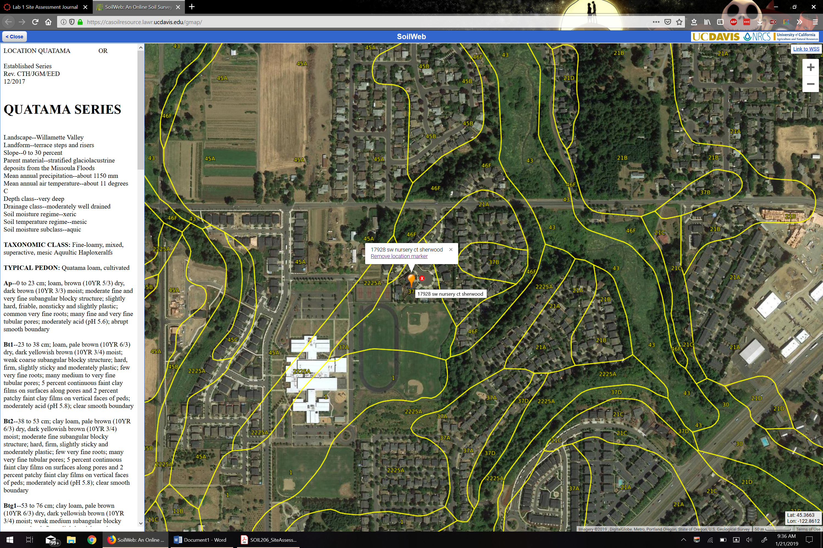

Established Series  
Rev. CTH/JGM/EED  
12/2017

**QUATAMA SERIES**

Landscape--Willamette Valley   
Landform--terrace steps and risers   
Slope--0 to 30 percent   
Parent material--stratified glaciolacustrine deposits from the Missoula Floods   
Mean annual precipitation--about 1150 mm   
Mean annual air temperature--about 11 degrees C   
Depth class--very deep   
Drainage class--moderately well drained   
Soil moisture regime--xeric   
Soil temperature regime--mesic   
Soil moisture subclass--aquic   
  
**TAXONOMIC CLASS:** Fine-loamy, mixed, superactive, mesic Aquultic Haploxeralfs   
  
**TYPICAL PEDON:** Quatama loam, cultivated   
  
**Ap**--0 to 23 cm; loam, brown (10YR 5/3) dry, dark brown (10YR 3/3) moist; moderate fine and very fine subangular blocky structure; slightly hard, friable, nonsticky and slightly plastic; common very fine roots; many fine and very fine tubular pores; moderately acid (pH 5.6); abrupt smooth boundary   
  
**Bt1**--23 to 38 cm; loam, pale brown (10YR 6/3) dry, dark yellowish brown (10YR 3/4) moist; weak coarse subangular blocky structure; hard, firm, slightly sticky and moderately plastic; few very fine roots; many medium to very fine tubular pores; 5 percent continuous faint clay films on surfaces along pores and 2 percent patchy faint clay films on vertical faces of peds; moderately acid (pH 5.8); clear smooth boundary   
  
**Bt2**--38 to 53 cm; clay loam, pale brown (10YR 6/3) dry, dark yellowish brown (10YR 3/4) moist; moderate fine subangular blocky structure; hard, firm, slightly sticky and moderately plastic; few very fine roots; many very fine tubular pores; 5 percent continuous faint clay films on surfaces along pores and 2 percent patchy faint clay films on vertical faces of peds; moderately acid (pH 5.8); clear smooth boundary   
  
**Btg1**--53 to 76 cm; clay loam, pale brown (10YR 6/3) dry, dark yellowish brown (10YR 3/4) moist; weak medium subangular blocky structure; hard, firm, slightly sticky and moderately plastic; few very fine roots; many medium to very fine tubular pores; 5 percent continuous faint clay films on surfaces along pores and 2 percent patchy faint clay films on vertical faces of peds; 2 percent fine distinct reddish brown (5YR 4/3) masses of oxidized iron, 2 percent fine distinct light brownish gray (10YR 6/2) iron depletions, and 5 percent fine distinct manganese coatings on surfaces along pores; moderately acid (pH 5.9); gradual wavy boundary   
  
**Btg2**--76 to 109 cm; loam, pale brown (10YR 6/3) dry, dark yellowish brown (10YR 3/4) moist; weak coarse subangular blocky structure; slightly hard, firm, slightly sticky and slightly plastic; common medium to very fine tubular pores; 25 percent faint clay films on all faces of peds; 10 percent fine distinct dark grayish brown (10YR 4/2) iron depletions on surfaces along pores; moderately acid (pH 6.0); gradual wavy boundary   
  
**Cg**--109 to 160 cm; loam, yellowish brown (10YR 5/4) dry, dark yellowish brown (10YR 3/4) moist; massive; hard, firm, slightly sticky and slightly plastic; common very fine tubular pores; 10 percent medium distinct grayish brown (10YR 5/2) and light brownish gray (10YR 6/2) iron depletions on surfaces along pores and 10 percent fine distinct yellowish red (5YR 4/6 and 5YR 5/8) masses of oxidized iron on surfaces along pores; moderately acid (pH 6.0)   
  
**TYPE LOCATION:** Washington County, Oregon; about 30 m east of the road in the southeast corner of the SW1/4NW1/4NE1/4 of section 9, T. 2 S., R. 2 W.; latitude 45.4089317, longitude -122.9468801, datum WGS 84 (coordinates estimated from PLSS details)   
  
**RANGE IN CHARACTERISTICS:**   
Mean annual soil temperature--12 to 13 degrees C   
Moisture control section--dry 45 to 60 consecutive days following summer solstice   
Depth to the argillic horizon--18 to 23 cm   
Depth to aquic conditions--40 to 75 cm   
  
Particle-size control section   
*Clay content--27 to 35 percent   
*Total fragment content--0 percent   
  
A horizon   
Hue--10YR, 7.5YR   
Value--3 or 4 moist, 5 or 6 dry   
Chroma--2 or 3 moist or dry   
Fine-earth texture--loam, silt loam   
Clay content--18 to 27 percent   
Sand content--20 to 40 percent   
Reaction--5.6 to 6.0   
Thickness--18 to 23 cm   
  
Bt and Btg horizons   
Hue--10YR, 7.5YR   
Value--3 or 4 moist, 5 or 6 dry   
Chroma--3 or 4 moist or dry   
Fine-earth texture--clay loam, silty clay loam   
Clay content--27 to 35 percent   
Sand content--25 to 45 percent; greater than 15 percent fine sand or coarser   
Reaction--5.6 to 6.0   
Thickness--85 to 130 cm   
  
Cg horizon   
Hue--10YR, 7.5YR, 2.5Y   
Value--3 to 5 moist, 4 to 6 dry   
Chroma--4 or 6 moist or dry   
Fine-earth texture--loam, sandy loam   
Clay content--12 to 18 percent   
Sand content--40 to 70 percent   
Reaction--5.6 to 6.0   
  
**COMPETING SERIES:**   
[Deadmanbay](https://soilseries.sc.egov.usda.gov/OSD_Docs/D/DEADMANBAY.html)--densic contact at a depth of 100 to 150 cm   
[Doolyville](https://soilseries.sc.egov.usda.gov/OSD_Docs/D/DOOLYVILLE.html)--greater than 10 percent rock fragments in particle-size control section; aquic conditions 30 cm from the soil surface   
[Killebrew](https://soilseries.sc.egov.usda.gov/OSD_Docs/K/KILLEBREW.html), [Mitchellbay](https://soilseries.sc.egov.usda.gov/OSD_Docs/M/MITCHELLBAY.html), [Sucia](https://soilseries.sc.egov.usda.gov/OSD_Docs/S/SUCIA.html)--densic contact at a depth of 50 to 100 cm   
[Stockel](https://soilseries.sc.egov.usda.gov/OSD_Docs/S/STOCKEL.html)--aquic conditions 40 cm from the soil surface; sand fraction ranges to more than 45 percent in the particle-size control section   
  
**GEOGRAPHIC SETTING:**   
Elevation--30 to 125 m   
Climate--warm, dry summers; cool, moist winters   
Mean annual precipitation--1000 to 1300 mm   
Mean annual air temperature--11 to 12 degrees C   
Mean January air temperature--3 degrees C   
Mean July air temperature--19 degrees C   
Frost-free period--165 to 210 days   
  
**GEOGRAPHICALLY ASSOCIATED SOILS:**   
[Aloha](https://soilseries.sc.egov.usda.gov/OSD_Docs/A/ALOHA.html)--no argillic horizon; in similar positions   
[Hillsboro](https://soilseries.sc.egov.usda.gov/OSD_Docs/H/HILLSBORO.html)--mollic epipedon; no aquic conditions within a depth of 150 cm; less than 15 percent sand in the particle-size control section; in similar positions   
[Huberly](https://soilseries.sc.egov.usda.gov/OSD_Docs/H/HUBERLY.html)-- fragipan; less than 15 percent sand in the particle-size control section; aquic conditions within 20 cm of the soil surface; in depressions of terraces   
[Verboort](https://soilseries.sc.egov.usda.gov/OSD_Docs/V/VERBOORT.html)--mollic epipedon; greater than 35 percent clay in the particle-size control section; cracks at surface in normal years; in depressions of terraces   
  
**DRAINAGE AND PERMEABILITY:**   
Drainage class--moderately well drained   
Saturation in normal years--apparent high water table at a depth of 40 to 75 cm below the surface in January through March   
Flooding--none   
Ponding--none   
Saturated hydraulic conductivity (Ksat)--moderately high   
  
**USE AND VEGETATION:**   
Use--production of berries, row crops, orchard crops, nursery stock, grain, seed crops, hay, and pasture   
Potential natural vegetation--Douglas-fir, western redcedar, Oregon white oak, Oregon ash, Oregon grape, grasses   
  
**DISTRIBUTION AND EXTENT:** Tualatin Valley and northern Willamette Valley, Oregon; MLRA 2; small extent   
  
**SOIL SURVEY REGIONAL OFFICE (SSRO) RESPONSIBLE:** Portland, Oregon   
  
**SERIES ESTABLISHED:** Washington County, Oregon; 1975   
  
**REMARKS:**   
Diagnostic horizons and other features in this pedon   
*Ochric epipedon   
*Argillic horizon--zone from 23 to 109 cm   
*Aquic conditions--zone from 53 to 160 cm   
  
The Quatama soils are mapped on the Senecal geomorphic surface as recognized in the Willamette Valley.   
  
8/2017-- This official series description was updated according to SSR01 Technical Note 11--Content and Format of Official Series Descriptions (revised 12/2015). Most of the changes made were in formatting. No major technical changes were made.   
  
**ADDITIONAL DATA:**   
Characterization data--pedon number S68 Oreg 34- 1, sample number S99OR-067-001, Riverside Soil Survey Laboratory; Lincoln, NE; 5/01; unpublished

National Cooperative Soil Survey   
U.S.A.